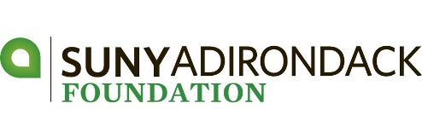
lyman a. beeman, jr. golf tournament
APPLICAtion for ENTRY – MAY 31, 2019

Thank you to our Tournament Sponsor:
DATE | Friday, May 31, 2019 (Kindly register by May 24)
TIME | Registration & Lunch begin at 11:30 am Shotgun Start – 1:00 pm
PLACE | Hiland Park Country Club – 195 Haviland Rd - Queensbury
ENTRY FEE | $640 – Foursome $160 – Individual Player
 | Includes: lunch, golf, cart, driving range, gift & cocktail reception
FORMAT  PRIZES | Four Person Scramble  Tournament Low Gross | 1st – 2nd – 3rd Place Net  Low Women’s Net | Longest Drive Men and Women  Closest to the Pin Men and Women  Putting Contest and Raffle
AGAIN THIS YEAR  SUPER TICKET | Include $30 in your registration fee (per player). This entitles each player to a gimme, putting contest and 50 PICK-A-PRIZE raffle stubs. Tickets will be handed out during registration.

Thank you to our Post-Doctoral Sponsor:

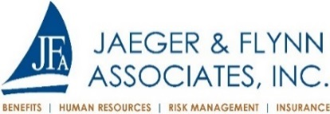

Company/Team Name
Captain – Player #1 |  | Handicap -
E-mail Address
Address | 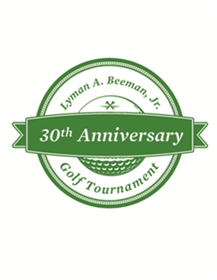
City, State, Zip Code
Phone
Sponsorship
Amount Enclosed
Make check payable to: SUNY Adirondack Foundation OR make a secure credit card payment at sunyacc.edu/beemangolf

Tax Deduction - $70 per player – FEDERAL TAX ID # 22-2486001 REGISTRATION DEADLINE – May 24, 2019

Thank you to our Doctoral Sponsors:
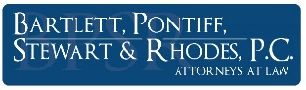

Player Names | Handicap | PAYMENT INFORMATION
#2 |  | Enclosed please find payment:  ☐$640 – Foursome  ☐$760 – Includes Foursome $640 and SUPER TICKET ($30 per player):  - Gimme  - Putting Contest  - 50 Pick-A-Prize Raffle Stubs  ☐$______________ – Sponsor (Circle One)  Doctoral ($2,500) | Master ($2,000) | Bachelor ($1,500  Associate ($1,200) | Hole-in-One ($750) | Prize ($300)  ☐$200 – Tee Sign  ☐$160 player  ALL PROCEEDS HELP SUPPORT STUDENT SCHOLARSHIPS  AT  SUNY ADIRONDACK  ☐$30 SUPER TICKET  Total - $____________
e-mail -
#3
e-mail -
#4
e-mail -
FOR MORE INFORMATION
Web: sunyacc.edu/beemangolf
Phone: 518-743-2243
E-mail: foundation@sunyacc.edu
For your convenience: A fillable Registration Form is available online at sunyacc.edu/beemangolf

