2019 SPONSORSHIP OPPORTUNITIES

B

May 31 2019

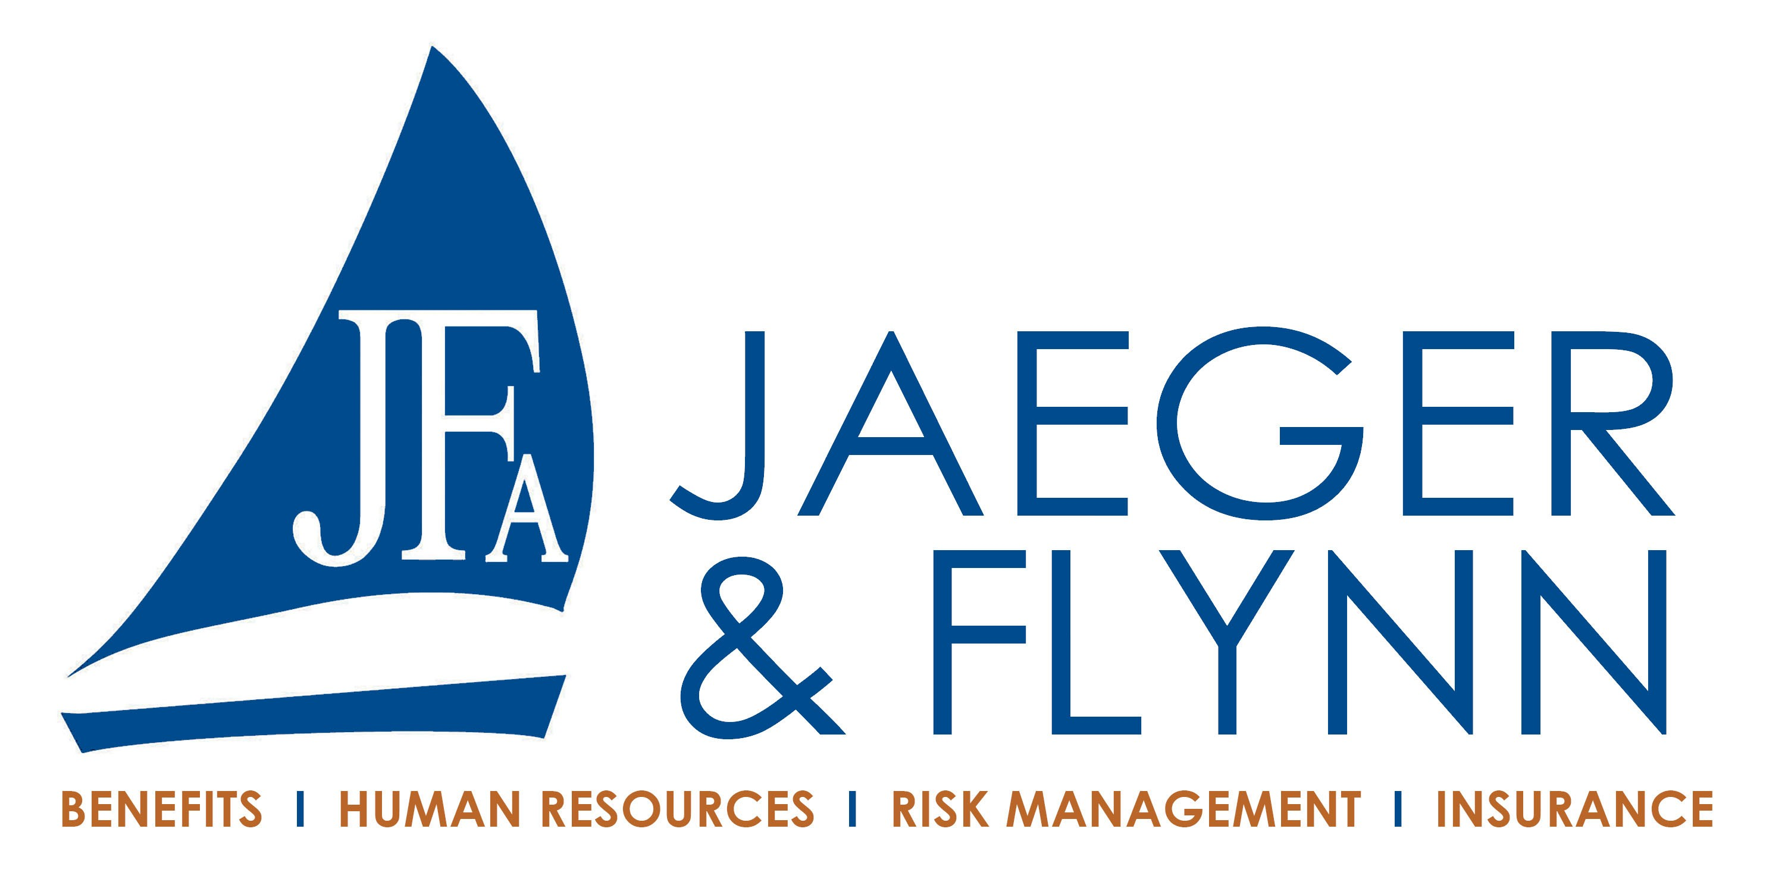

TOURNAMENT SPONSOR $5,000

Two $500 scholarships (Fall & Spring) in your company’s name to a student in 2019 - 2020
- Logo on Save the Date & Registration

Logo on player gift
Top levels include golf for eight, listing in tournament program and website, signage on the course

POST-DOCTORAL SPONSOR $4,000

One $500 scholarships in your company’s name to a student in 2019 - 2020

Logo on Save the Date & Registration
- Logo on player gift
Top levels include golf for four, listing in tournament program and website, signage on the course

DOCTORAL SPONSOR $2,500

One $500 scholarship in your company’s name to a student in 2019-2020
- Exclusive Sponsorship opportunity – choice of:
  - Player gift bag
  - Sponsor Spotlight
  - Beverage Tickets
  - 19th Hole Reception Sold Out
  - Golf Carts - Sold Out

Logo on Registration

Top levels include golf for four, listing in tournament program and website, signage on the course

MASTER SPONSOR $2,000

Exclusive Sponsorship opportunity – choice of:
- Bag Drop Off
- Golf Clinic
- Clubhouse Raffle
- Snacks station on course

Top levels include golf for four, listing in tournament program and website, signage on the course

BACHELOR SPONSOR $1,500

Shared sponsorship of lunch
Top levels include golf for four, listing in tournament program and website, signage on the course

ASSOCIATE SPONSOR $1,200

Signage at the putting contest

Top levels include golf for four, listing in tournament program and website, signage on the course

HOLE IN ONE SPONSOR $750

Sponsor of the hole in one prize for a single par 3
- Two Golfers

Top levels include listing in tournament program and website, signage on the course

PRIZE SPONSOR $300

(No Golf)
- Logo on Prize Envelopes
- One drink ticket per player
- Logo on website
TEE SIGN $200
(No Golf)
- Sign at hole

SUNY Adirondack Foundation | 640 Bay Road, Queensbury, NY 12804 | Phone: 518.743.2243 | foundation@sunyacc.edu

