What is RWG? RWG is a software that makes the web, documents and files more accessible - any time, any place, and on any platform or device. From reading on-screen text aloud to researching and checking written work, Read & Write Gold makes lots of everyday tasks easier.
How do I download it?
- Head to https://www.texthelp.com/confirmation/readandwrite-product-trial-confirmation/
- Next complete the Start your Free Trial Section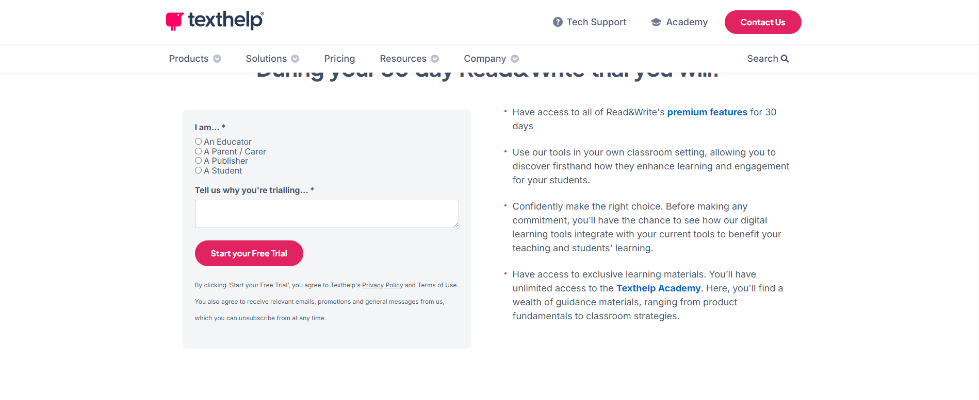
- Choose the correct download for your platform (Chrome Users will also need to download an extension from the Google Play Store)
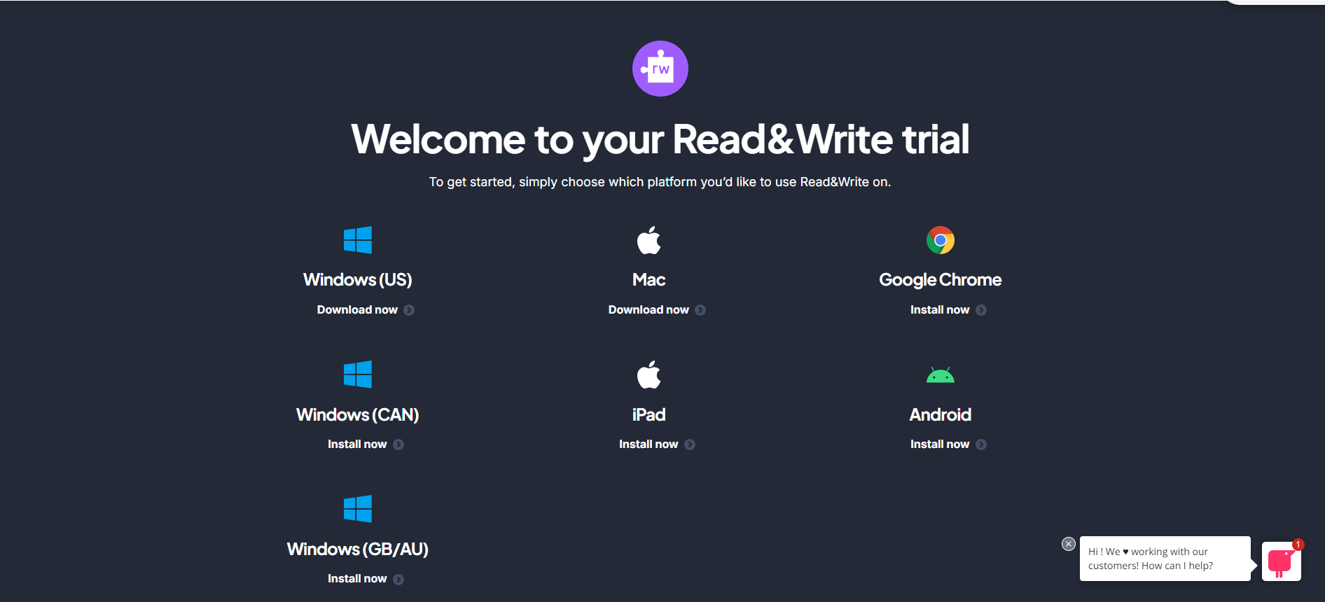

- Once Downloaded and the toolbar appears at the top of your screen, Sign Into your SUNY Adirondack Wolfmail Account to get full access

How do I use RWG? Here is a list of helpful and information short videos for users
Videos for Windows Users
Videos for Chrome Users
Videos for Mac Users

