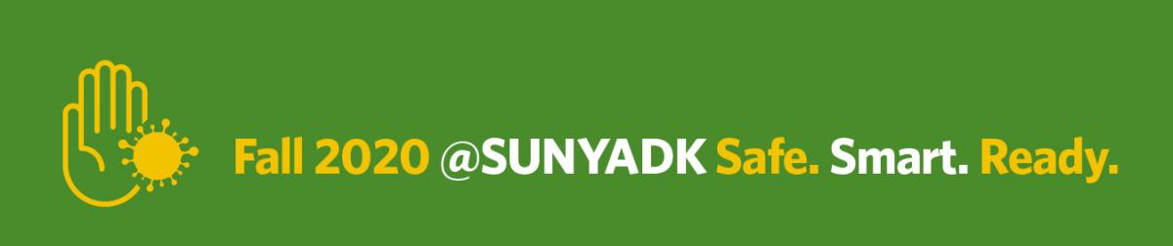
Guidelines for all who come to campus
SUNY Adirondack is ready to welcome students and employees back to campus in a limited capacity. The college is following all federal and state public health and safety guidelines and requires everyone visiting any of our three locations to do so as well.
We ask all who enter campus to adhere to the following health and safety protocols:
CAMPUS ENTRY CHECKPOINTS: When you arrive at any of our three locations, you will be required to stop at a CampusClear checkpoint. These will be located at the Haviland Road entrance on the Queensbury main campus (opens at 6:30 a.m.), and at the front desks at our Saratoga site in Wilton (opens at 7:30 a.m.) and our Culinary Arts Center in Glens Falls. You must have a face covering on when entering the checkpoint.
HEALTH ASSESSMENT/SCREENING: You will be required to show proof of a health self-assessment to the checkpoint attendant. The most efficient way to navigate this checkpoint is to download the free CampusClear app available for smart phones. If you have not completed the digital app prior to arrival, you will be required to answer a series of assessment questions at the checkpoint. This may delay your entrance, please plan accordingly. Once cleared to be onsite, you will be given a wristband, which will provide you access to campus for that day only.
FACE COVERINGS REQUIRED: Properly worn face coverings are required for everyone indoors, except when alone in private offices or in single use spaces. They are also required outside if social distancing of at least 6 feet cannot be achieved.
PRACTICE SOCIAL DISTANCING: Everyone inside buildings is required to follow the one-way directional signage, maintain 6 feet between you and all other people whenever possible, and follow any social distancing signage present in many locations.
WASH YOUR HANDS: Please remember to wash your hands frequently and thoroughly. Hand sanitizer is also available throughout campus in every building for your use.

Thank you for adhering to these guidelines while visiting our campus. Keeping our community safe is our collective responsibility.

